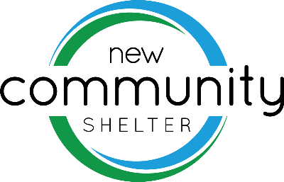  RESIDENT PERSONAL NEEDS  -Water Bottles  -Towels – Bath size  -Antiperspirant  -Shaving Cream  -Razors (men’s & women’s)  -Winter Wear  -Thick Winter Gloves & Hats  -Scarves  -Hand/Foot Warmers  -Backpacks  -Umbrellas/Ponchos  -Shampoo & Conditioner  -Body Wash  -Twin size bedding/blankets  -Pillows  -Men’s & Women’s Flip Flops  EVERY DAY &  CURRENT NEEDS | 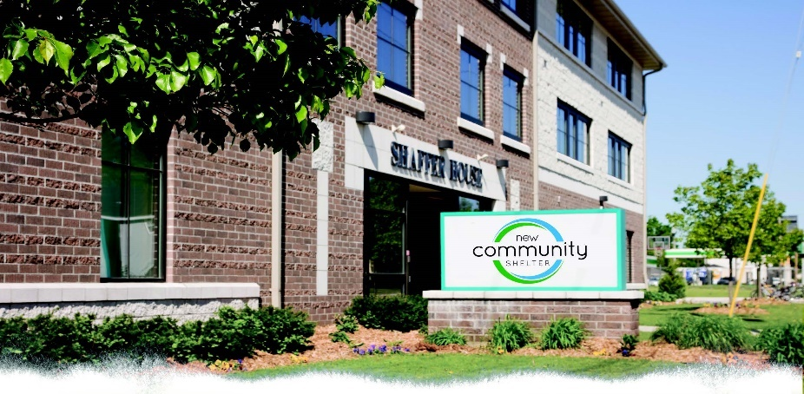  COMMUNITY MEAL PROGRAM  & KITCHEN  -Electric & Manual Can Openers  -Silverware – Forks & Spoons  -ZipLock Sandwich Bags  -Coffee, Creamer & Sugar  -Cheese Slicer  -Hair Nets/Bandanas/Hats  -Canned Fruit & Vegetables  -Fresh Fruit & Vegetables  -Fruit Cups  -Juice Mix or Concentrate  -Aprons  -Dish Cloths  -Napkins/Paper Towel  -To Go Containers  -Plastic Forks & Spoons  -Small Cups w/Lids | SHELTER SUPPLIES  -Garbage Bags-33 & 56 gallon  -Bathroom Cleaner  -Paper Towel  -Scotch Brite Pads  -Brooms & Dust pans  -Toilet Bowl Cleaner  -Disinfectant Cleaner  -Toilet Paper  -Batteries (AA needed most)  -Bleach Cleaner  -Mop Soap  -Dish Soap  -HE Laundry Soap  -Vinegar  -Gloves for Cleaning (M, L, XL)
SHELTER WISH LIST  -AM/PM Pocket Pill Boxes  -Gas Cards  -Shark Navigator Deluxe Vacuum  -Bikes-Men’s/Women’s  -Steel Toe Boots (sz. 10-13)  -Gift Cards for Supplies & Barrier Reduction Fund  -Walmart  -Home Depot  -Sam’s Club  -Costco  -Menards | GARDEN & GROUNDS SUPPLIES  -Shovels  -Ice Melt  -Gas Generators  -Garden Wagons/ Yard Carts  PROGRAMMING NEEDS  -Pens  -Folders  -Notebooks  -Envelopes & Stamps  -Resume Paper  Other ways to give:  -Drop off donations at the front desk or they can be mailed to the New Community Shelter  -Amazon Smile -5% of your purchases are donated to the shelter when chosen as your supporting cause  -www.newcommunityshelter.org by clicking on the donate tab on the home page  -Through our Facebook page: New Community Shelter  -Over the phone by contacting Kris @ (920)437-3766 x102 | ***ALL BOLD ITEMS ARE THINGS WE ARE IN NEED OF NOW, IN SHORT SUPPLY OF OR OUT OF!  For more info please contact:  Terri Refsguard; CEO  301 Mather St.  Green Bay, WI 54303  920-437-3766  TerriR@newcommunityshelter.org

